UNIT 1: MY HOBBIES
A. PHONETICS
1. Find the word which has a different sound in the part underlined. Read the words aloud.
1. A. game B. arrange C. skate D. cake
2. A. hobby B. doll C. collect D. over
3. A. difficult B. unusual C. uncle D. result
4. A. piano B. fish C. like D. badminton
5. A. rest B. help C. garden D. identify
2. Put the words in the box into two groups.
world arrange service gardening model
pottery melody sunburn surfing expert

/ə/ | /ɜ:/
__________  __________  __________  __________  __________ | __________  __________  __________  __________  __________

B. VOCABULARY & GRAMMAR
1. Find the odd one out A, B, C or D.
1. A. cycling B. cooking C. evening D. gardening
2. A. play B. swim C. collect D. photo
3. A. horse-riding B. challenging C. bird-watching D. mountain-climbing
4. A. usual B. write C. walk D. eat
5. A. pottery B. enjoy C. flower D. wood
2. Circle A, B, C, or D for each picture.
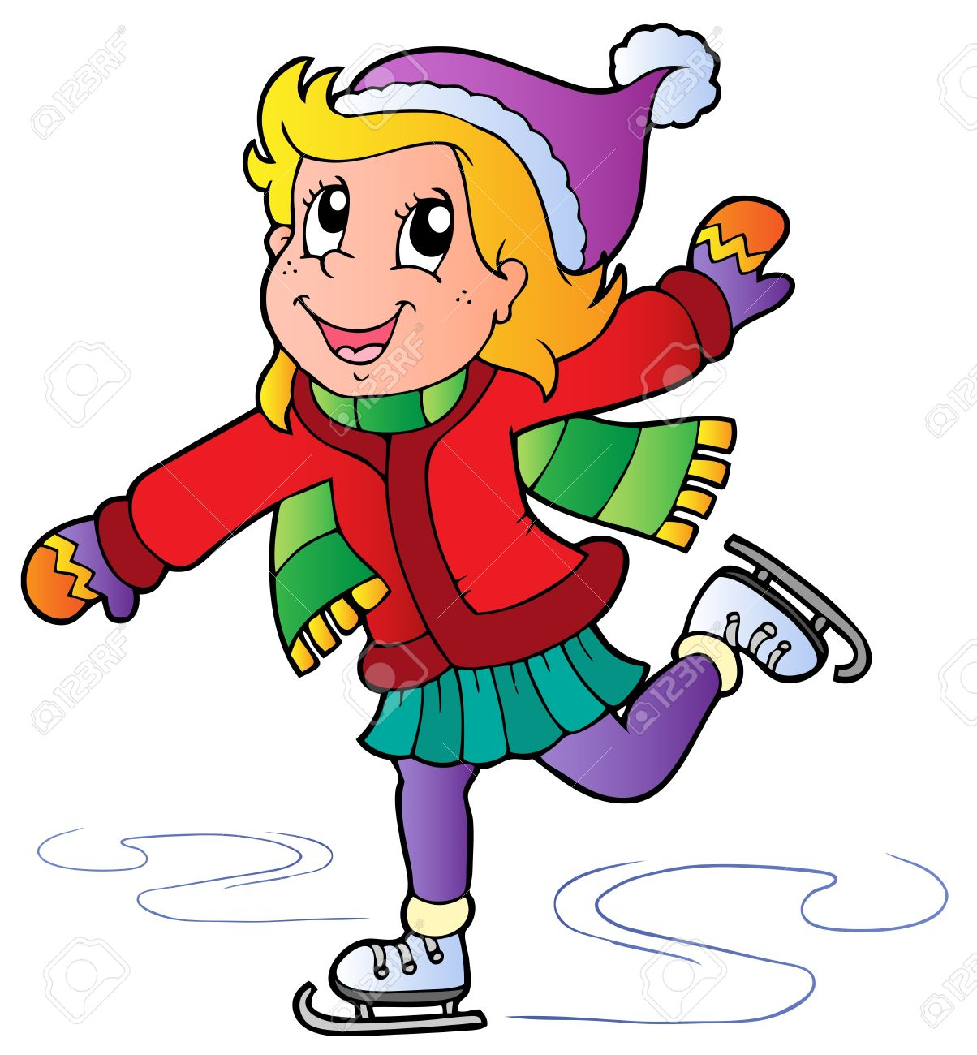  1.  A. skating  B. singing  C. dancing  D. cooking | 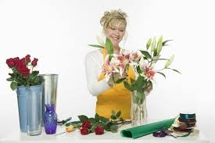  2.  A. bird-watching  B. taking photos  C. arranging flowers  D. playing board games
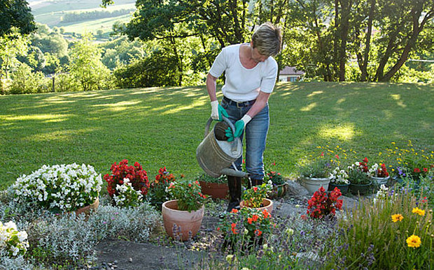  3.  A. collecting  B. taking  C. gardening  D. climbing | 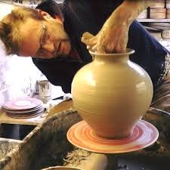  4.  A. making models  B. making pottery  C. carving wood  D. collecting dolls
3. Put the verbs in brackets in the correct tense form.
1. You (think) __________ collecting stamps costs much money?
2. My father thinks mountain climbing (be) __________ more dangerous than skating.
3. Every year, my mother (give) __________ me a nice doll on my birthday.
4. My brother (not like) __________ collecting stamps, he likes collecting glass bottles.
5. My sister likes (cook) __________ very much. She can cook many good foods.
6. Does your brother like (listen) __________ to music in his free time?
7. I think in the future, more people (enjoy) __________ going out by bicycles.
8. My father says when he's retired, he (go) __________ back to his village to do the gardening.
9. We are planting trees around our school now. Our school (be) __________ surrounded by a lot of green trees.
10. Lan says she loves collecting pens but she (not/continue) __________ this hobby from next year.

C. READING
1. Read the conversation and answer the questions.
Hoa: What’s your favorite hobby, Minh?
Minh: Well, it’s drawing.
Hoa: How many paintings do you draw?
Minh: Er... I don't remember. It’s around 100.
Hoa: Is your painting on the wall?
Minh: Yes, it is. It’s one of my favorite ones.
Hoa: How nice it is! I love the colors in your picture.
Minh: Thanks. And what’s your hobby, Hoa?
Hoa: Er, ... I can’t draw. But my hobby is collecting pictures and paintings.
Minh: Really? I will give you one.
Hoa: Thank you.
Questions:
1. Does Minh like drawing?
…………………………………………………………………………………………………..
2. How many paintings does he draw?
…………………………………………………………………………………………………..
3. Is there any painting on the wall?
…………………………………………………………………………………………………..
4. What is the painting like?
…………………………………………………………………………………………………..
5. What’s Hoa’s hobby?
…………………………………………………………………………………………………..
2. Choose the correct word A, B or C for each gap to complete the following passage.
Hi. My name’s Mai. I am a student (1) __________ a secondary school in Lang Son. My friends often say I have an unusual hobby.
I have a little notebook. I always have it (2) __________ me. I try to fill (3) __________ one page a day. Can you guess (4) __________ I fill in each page of my notebook? Well, it is English (5) __________. Sometimes I put words in (6) __________, like fruit - all kind of fruits, you know? Or color, or clothes, or things and the shops where you (7) __________ them. I have (8) __________ grammar pages where I write irregular verbs, or a page (9) __________ prepositions. I think prepositions are difficult, you know – on Sunday, in the morning, listen to a concert - but you say phone someone. In Vietnamese, we say phone to someone. Do you think my hobby is unusual? Do you have any favorite hobby? Please (10) __________ it with me!
1. A. in B. at C. on
2. A. with B. of C. along
3. A. on B. with C. X
4. A. which B. what C. when
5. A. letters B. words C. lines
6. A. groups B. pairs C. meanings
7. A. buying B. buy C. classroom
8. A. any B. some C. a
9. A. of B. for C. in
10. A. tell B. talk C. share

D. WRITING
Can you correct the passage? Write the correct version.
My father has unusual hobby carving eggshells as everyone knows eggshells are very fragile my dad can make beautiful pieces of art from empty eggshells it’s amazing he started the hobby five years ago after a trip to the us where he saw some carved eggshells in an art gallery my father did not go to class to learn how to carve he learned everything from the internet.
…………………………………………………………………………………………………..
…………………………………………………………………………………………………..
…………………………………………………………………………………………………..
…………………………………………………………………………………………………..
…………………………………………………………………………………………………..
…………………………………………………………………………………………………..
…………………………………………………………………………………………………..
…………………………………………………………………………………………………..
…………………………………………………………………………………………………..
…………………………………………………………………………………………………..
…………………………………………………………………………………………………..
…………………………………………………………………………………………………..

