ENGLISH 7- REVISION

A. PHONETICS
Ex 1. Find the word which has a different sound in the part underlined. Read the words aloud.
1. A. allergy B. calorie C. coordinate D. triathlon
2. A. compound B. concentrate C. monopoly D. melody
3. A. essential B. attention C. vegetarian D. depression
4. A. sick B. swimming C. itchy D. riding
5. A. really B. healthy C. regularly D. identify
Ex 2: Put the words in the box into two groups
vast | fast | save | fault | leave
leaf | surfing | feel | very | give

/ f / | / v /
______________________________  ______________________________  ______________________________  ______________________________  ______________________________ | ______________________________  ______________________________  ______________________________  ______________________________  ______________________________
B. VOCABULARY AND GRAMMAR
Ex 1 : Find the odd one out A, B, C or D.
1. A. cough B. weak C. headache D. sore throat
2. A. sunburn B. toothache C. earache D. unhealthy
3. A. sick B. temperature C. tired D. weak
4. A. flu B. stomachache C. allergy D. fat
5. A. sleep B. happy C. live D. smile
Ex 2 : Circle A, B, C or D for each picture.
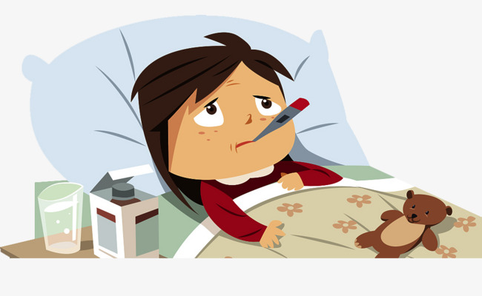  1.  A. have a cough  B. have a headache  C. have a sore throat  D. have a temperature |   2.  A. have flu  B. have stomachache  C. have toothache  D. have earache
  3.  A. feel sick  B. feel tired  C. Feel weak  D. Feel sleepy |   4.  A. wearing a sun hat  B. washing face  C. Washing hands  D. doing exercise

Ex 3: Put the verbs in brackets in the correct tense form.
1. Nam looks brown. He was on holiday last week. He (get)……………………………sunburn.
2. Getting plenty of rest is very good. It (help)……………………….you to avoid depression.
3. The Japanese (eat)………………………..a lot of fish, so they are very intelligent.
4. If you wash your hands more, you (have)…………………….less chance of catching flu.
5. Eating carrots regularly (help)……………………….you see better.
C. READING
Ex 1: Put a word from the box in each gap to complete the following passage.
fresh | drink | eat | rice | healthy
school | water | fish | breakfast | well
It’s important to (1)……………………..well, especially when you are studying. If you are at primary (2)……………………., you may not go home for lunch and have a cooked meal of meat or (3)…………………………and vegetables. A chicken and lettuce sandwich, with some (4)…………..…..fruit would be a light but (5)……………..….. Many people around the world eat plain, boiled (6)……………………two or three times a day.
Pupils and students often don’t eat (7)…………….………when they’re revising for exam – they eat chocolate and (8)……………………..lots of black coffee! And by the way, doctors say everybody should start the day with healthy (9)…………………… It’s also good for you to drink a lot of (10)…………..……….through the day.
Ex 2: Read the conservation and answer the questions
Phong: What time do you usually come home from school?
Nick: I usually come home at 11.30.
Phong: When do you often have lunch?
Nick: I often have lunch at 12 o’clock.
Phong: What do you usually have for lunch?
Nick: I often have fish and eggs.
Phong: What do you do after dinner?
Nick: I sometimes go to the cinema, but I usually stay at home, watch TV and do my homework.
Phong: Do you often watch TV?
Nick: Yes, I do. I like watching sports very much.
Phong: When do you go to bed?
Nick: I always go to bed at 9.30. I never stay up late.
Questions:
1. What time does Nick usually come home from school?
……………………………………………………………………………………………………
2. When does he often have lunch?
……………………………………………………………………………………………………
3. What does he usually have for lunch?
……………………………………………………………………………………………………
4. What does he often do after dinner?
……………………………………………………………………………………………………
5. What TV programme does he like watching?
……………………………………………………………………………………………………
D. WRITING
Ex 1: Make sentences using the words and phrases given.
Example : Dr. Minh / diet / expert/ . à Dr. Minh is a diet expert.
1. Getting/ plenty / rest / really / important.
……………………………………………………………………………………………………
2. It / easy / get / flu / . / we / should / try / keep / clean / more/ .
……………………………………………………………………………………………………
3. I/ have / toothache / yesterday / because / I eat / many / sweets / .
……………………………………………………………………………………………………
4. He / has/ flu / . / he / keep / sneezing / coughing / .
……………………………………………………………………………………………………
5. Which / activity / use / more / calories / walking / or / riding / bicycle/ ?
……………………………………………………………………………………………………
Ex 2: Can you correct the passage? Write the correct version.
I would like to live in a place where there are four seasons in spring there are a lot of beautiful flowers there are a lot of tall trees in front of my house there are walk paths around my house and they are all clean there are a lot of ponds and lakes near my house so I can go fishing every afternoon I also would like to have a sport center near my school so I can play some sports after class.
……………………………………………………………………………………………………
……………………………………………………………………………………………………
……………………………………………………………………………………………………
……………………………………………………………………………………………………
……………………………………………………………………………………………………
……………………………………………………………………………………………………
……………………………………………………………………………………………………
……………………………………………………………………………………………………
……………………………………………………………………………………………………

THE END

